# Installation Document:

Before installing the webwork-plugin the following actions needs to be taken.

1. Change the bb-manifest.xml in the WEB-INF/bb-manifest.xml according to the university as follows,

<plugin> <name value=*"WeBWorK Assignment"* />

To the value of what is needed in the university website. The handle value in the plugin,

<handle value=*"WebworkAssignment"* />

should be changed to any value that is required. If this is changed, then it should be updated with the property “BuildingBlockConstants.BuildingBlockName” in the messages.properties file at WEB-INF/classes/edu/Missouri/messages.properties as the following,

BuildingBlockConstants.BuildingBlockName=WebworkAssignment

1. Next, the vendor information needs to be updated, as follows,

<vendor>

<id value=*"UOM"* />

<name value=*"University of Missouri"* />

<url value=*"http://www.missouri.edu/"* />

<description value=*"WeBWorK Assignment"* />

</vendor>

The ID information should be available over properties file, as,

BuildingBlockConstants.VendorName=UOM

1. Next, the content handlers as follows, should be updated with the properties file as well,

<content-handlers>

<content-handler>

<name value=*"WeBWorK Assignment"* />

<handle value=*"resource/x-BbWw-Assign3"* />

BuildingBlockConstants.BuildingBlockContentHandlerType=resource/x-BbWw-Assign3

The value set by the name field is the one, which will be available with the Menu in Blackboard. Change the name value according to the needs.

1. Finally, permissions to be set as follows,

<!-- Permissions for the class folders to make network connections. -->

<permission type=*"java.net.SocketPermission"* name=*"webwork.math.missouri.edu"*

actions=*"connect,resolve"* />

<permission type=*"java.net.SocketPermission"* name=*"webwork.math"*

actions=*"connect,resolve"* />

The website for the webwork site should be given permission. For the above statements, the website was, <http://webwork.math.missouri.edu/webwork2>.

The properties to be changed in the message.properties file are available in the first few lines.

1. After installing the plugin, the Settings link in the Building blocks page should be available as shown below,



When clicking on it, the admin page with default settings filled should be available. Please go through the next steps on how to set up the admin page.

1. Enter the web-server locations as specified below,

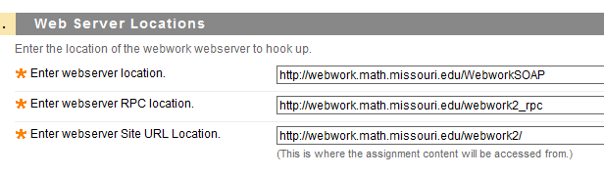

For webserver location – add WebworkSOAP to the normal URL.

For webserver RPC location – add webwork2_rpc to the normal URL.

For webserver Site URL location – add webwork2/ to the normal URL. Don’t forget the ‘/’ in the site URL location.

1. Enter the Permission and keys as follows,

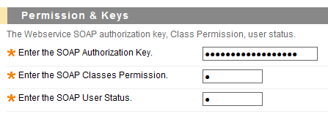

Auth Key, Classes Permission (Usually ‘0’), SOAP User Status (Usually ‘C’).

These data are written back to the webwork server. If the values are not perfect, it might lead to incorrect execution / exception.

1. Enter the data security level as below,

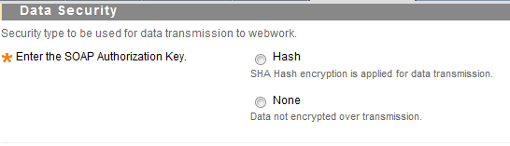

The first choice transfers data to webwork by hashing the field contents. If none is selected, the plaint text is transmitted.

1. Enter the Optional Search items, as below

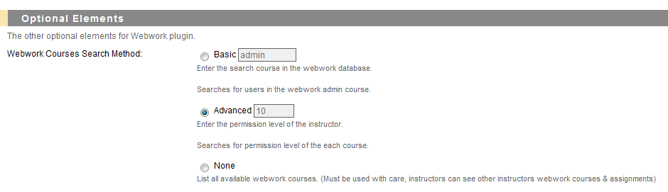

The Search mechanism types are

**Basic** – Searches for a course specified, to have a list of course users and the courses offered in the webwork. Usually this course is named admin. It might change with specific deployments. Thus, this method returns only the courses for the current professor available with the ‘admin’(might change) course.

**Advanced** – Searches for a course with permission level of 10 in a course. Thus for the professor, a course offered in webwork should have a permission level of 10 or the specified value.

**None** – All webwork courses are listed for each professors. (Dangerous, use with caution.)

Now, you are set up with the blackboard building block.

Report any errors/issues to Jason Aubrey.